**PROJECT PROPOSAL DOCUMENT FOR ONLINE BOOKSTORE APPLICATION**

**BY:**

**SENKOOTO DAVIS JOHN**

**2020–B072-20123**

**Project Proposal: flamingo book store application**

1. **INTRODUCTION**

The Flamingo Book Application aims to revolutionize the way readers discover, read, and interact with books. Leveraging the latest in mobile technology, social networking, and artificial intelligence, Flamingo Book offers a seamless and engaging platform for book lovers of all ages. This proposal outlines the key features, target audience, development plan, and potential benefits of the Flamingo Book Application.

This project aims at demonstrating how to design and develop a favorite android online bookstore application for different literature loving students, at a certain college who love exploring new and old books which they will use even when they are gone for holidays, traveling on a bus as they are exploring some new books.

To make online book shopping more interactive and user-friendly, the application allows users to register an account, login, search for particular books of interest

This project also connects and communicates with a database server through the internet using Hypertext Preprocessor (PHP). The data is primarily stored on the server but are also loaded and stored on the mobile phone’s database in the event of lack of internet access.

Furthermore, to create a smooth and great user experience, the application does not only check if the user already exists but can add new information for a new user or update new logins on the database. The application protects the user’s password with an encryption. This project also provides a way to recommend the application to friends via email.

**1.2. Project Description**

flamingo book store is a digital sanctuary for book lovers like , offering a vast collection of literature treasures conveniently from the comfort of your fingertips. With an interesting interface and a diverse range of genres, we aim at cater for every reader’s taste and preference.

Enjoy peace of mind while shopping with our secure payment gateway, ensuring the safety of your transactions and sensitive information, Stay updated with the author’s spotlights, featuring interviews, book signings and exclusive content from your favorite authors, our dedicated customer support team is also available to assist you in every step of the way, ensuring a seamless and enjoyable shopping experience.

**PROBLEM STATEMENT**

In today’s fast paced world, traditional bookstores face difficult times keeping up with the changing requirements, and preferences of current modern consumers. While the love for literature remains strong, the ease and accessibility provided by online sellers have completely changed how people find and buy books.

The production and distribution of books contribute to environmental issues such as deforestation, carbon emissions, and waste generation prompting eco-conscious consumers to seek more sustainable alternative.

With hectic schedules and busy lifestyles, many readers struggle to find the time to visit a physical bookstore, hindering their ability to explore new titles and authors.

The process of browsing through shelves, searching for a specific title, and standing along checkout queue can be time consuming for consumers.

Traditional bookstores may have limited shelf-space, resulting in a constrained selection of books and genres. This limitation fails to cater for the diverse interests and preferences of readers.

**1.3. Objectives**

**1.3.1. Main Objectives**

To develop an android online mobile application that literature college students would use even when they are on the go.

To also provide a convenient, accessible and diverse platform for individuals to discover, purchase, engage with literature but also to foster a deeper appreciation for literature and cultivate a thriving online literary community.

**1.3.2. Specific Objectives**

To establish a platform that makes a vast array of books easily accessible to readers from a variety of demographics, places, and backgrounds.

To analyze the operations of the existing bookstore platforms services to conclude help for the research.

To design an automated online book store mobile application that is capable of storage and retrieval of data.

To develop an intuitive and user-friendly interface that makes browsing, searching, and purchasing easy.

To provide readers with a wide range of interests, tastes, and cultural backgrounds by curating a broad and diversified library of books.

To improve discoverability and engagement by providing curated lists, personalized book recommendations, and customized promotions.

To design an application that is compatible with other application programs.

**1.4. Purpose and scope of study.**

**1.4.1. Purpose**

Provide a user interface that allows users to browse the store and select books to purchase and read.

**1.4.2. Scope of the study.**

The main scope deliverables of the project are to:

Analyze and develop detailed specifications and requirements

Prepare high-level and detailed system design specifications

Prepare a test plan as well as test cases.

Develop the system and write the code.

Unit, integration, and system testing should all be performed.

Demonstrate a bug-free application after making any necessary changes.

1. **Literature Review**

When we use Google to search for educational applications, we will find a lot of options. However, there is some ambiguity in selecting suitable content at the proper time. Some applications have been developed that contain stories, novels, essays, and other types of content. Applications allow multiple parties involved in a commerce transaction to connect in order to shop for new, secondhand, rare, and out-of-print books. Review of literature for an online bookstore.

The prototype serves as a roadmap for establishing a solid Online Book Ordering System based on user feedback, notably from the perspective of academics, which will be handled by the university's book store. The arranging, however, is still done manually.

According to a software development firm, an e-catalogue delivers vital information about product specifications to potential customers. It makes it easier for potential customers to find the items they want in the format they want. It is the ideal and ideal product catalogue because it does not require printing, has no number or color restrictions, and does not require distribution. The system is described as self-updatable in a few simple clicks, with the content in the e-catalogue always being accurate and, best of all, requiring no reprinting. Furthermore, the e-catalogue promotes the products on its own, with greater interactivity, consumer personalization, and even a shopping cart for inquiries.

Amazon is one of the most popular online shopping sites that employ an e-catalogue to display their books. The website lists the many types of books that are available. The book cover can be found on the left side of the main frame, as well as the book description, which includes information such as the title, author, price, and number of volumes left to be sold, as well as customer ratings.

**2.2 Existing System**



**Figure 1: Amazon**

Amazon.com is the world's most well-known online bookshop, and it is the website that launched the online buying revolution. On Amazon.com, the customers may find almost any book in almost any edition.

**Strength**

The website is clean and straightforward, with a large search bar at the top that makes discovering books a breeze. There are several subcategories, and books are classified by department, format, author, promotions, prizes, languages, and other factors. Amazon.com also has a much larger selection of books in several languages than any of the other online bookstores listed here. There are also audiobooks and magazines available.

The user rating and book description part of Amazon.com is one of the best features, since it allows the user to make an informed decision before purchasing a book. The site also proposes books depending on the user's browsing habits, which can be very helpful and intuitive at times. Another important feature is a list of alternatives for whether the user wants a brand new.

**Weakness**

Amazon's shipping rates are unfortunately rather high, with ordinary shipments costing $4.99 (RM20) per shipment and $4.99 (RM20) per item for book purchases. The cost of shipping might easily exceed $29.99 (RM 125) each shipment. Priority courier delivery, as well as large and bulky shipments, can be rather costly. There are some items, however, that are eligible for free shipping with Amazon if the customers spend $25 (RM100) or more.

**3. RESEARCH METHODOLOGY.**

3.1. Research Methodology.

The first step in starting this project is gathering all of the necessary requirements in order to develop an application that is easy to maintain and meets user needs. The emphasis is primarily on study into various online bookstores that are already operational. Accordingly, questionnaires and interviews with target end users have been shown to be the most effective methods for gathering exact data from them. The design paradigm starts with a prototype of the graphical user interface (GUI) layer (using Figma) and then outlines the application's backend system, which is only visible to the portal's administrators. The prototype's construction is adjusted in response to end-user feedback in order to build an online book store that meets the project's requirements at the completion. Iteration occurs as the prototype is refined to meet the user's needs while also allowing the developer to gain a better understanding of what needs to be done. The application is then deployed on hosting to make it available via the internet after the GUI design prototype is finalized.

Within a software project, the Software Development Life Cycle (SDLC) is a process that is followed for a software project. It is a detailed strategy that describes how to build, maintain, replace, and change or improve particular software. The life cycle is a mechanism for enhancing software quality and the development process itself. During the software development process, numerous software development life cycle models have been established and designed. To assure success in the software development process, each process model follows a set of stages specific to its type. Agile Methodology is the model we are using for this project.

B 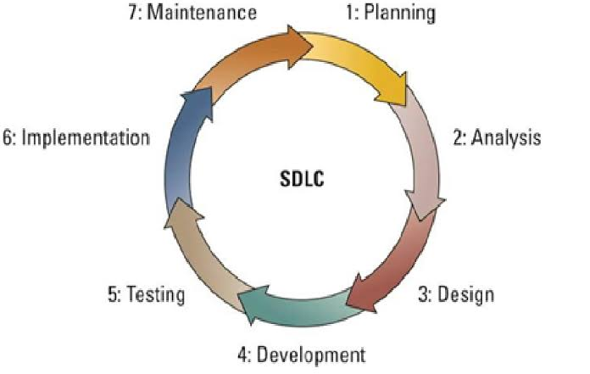

**Fig 2: Illustration of the SDLC.**

**3.2 Agile Methodology**

To deliver a smooth execution of the project, a methodology is to be chosen to assist in managing the project phase by phase, beginning with the initiation and ending with the closure. A methodology is necessary for selecting the best methods, practices, approaches, and procedures from among the many available. As a result, Agile Methodology is chosen for the development of the Online Book Store application(eBook). Agile technique is the ideal strategy to complete this project because it divides it into phases and requires constant adjustments and input until the final product is completed.

Agile methodology is an iterative project management strategy that allows a project to adapt to changing working conditions and develop in a short amount of time. In this method, which is referred to as "sprint," a project term is divided into shorter and repeatable stages. Sprint lengths were decided during the project's early planning stages and will be reflected in the final product.

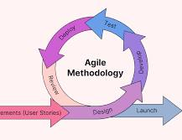

**Figure 3: Illustration of Agile Methodology**

**3.3 Process**

3.3.1 Research, Analysis and Gathering Requirement

This phase includes conducting literature reviews and analyses of existing systems in order to determine the requirements and features for an online book store application. Prepare documentation after evaluating the research study. Surveys and feedback are to be used to gather requirements. Requirements are subject to change over time. The prerequisites for the flamingo book store application are listed below:

A product catalogue on the welcome page

After a successful login, the user will be directed to this page. It will provide all of the book categories and provide a search keyword option for finding the desired title. It also has some unique elements, such as recommended titles and weekly special books.

Search

Search textbox provides the user with the option of searching by keyword. The book title should be used as the keyword.

Advanced Search

The user can utilize advanced search to find a book based on the title, author, category, and topics The total number of books that match the specific search criteria will be presented. The user can choose a book and add it to their shopping cart from here.

Book Description

If a user wants more information about a book, they can click on the title and be taken to a Book description page.

Shopping Cart

The users can manage a shopping cart that contains all of the books that they have chose. They can change, delete, and update the contents of their shopping cart. A final shopping cart summary is shown, which includes all of the products selected by the user as well as the overall cost.

Managing User Account

To access all of the application's functions, each user should create an account. Can log in and out using the login and logout pages, respectively. The database will save all of the user sessions.

**3.3.1 Project Design Phase**

In order to design an application, the relational database must be designed first. The data model and the process model are the two aspects of conceptual design. The data model specifies which data should be stored in the database, whereas the process model defines how the data should be handled. To put it another way, the data model is used to construct the relational tables of a relational database. The process model is used to design the queries that will access those tables and perform operations on them.

A decomposition diagram illustrates a system's top-down functional decomposition and highlights its structure. The goal of the functional decomposition is to break down a system step by step, starting with the system's main function and progressing through the intermediate levels to the level of basic functions. More extensive process diagrams, such as Data Flow Diagrams (DFD) start with this diagram. Data Flow Diagrams illustrate the flow of data from external entities into the system, as well as from one process to the next. A DFD can be drawn using four symbols:

*Rectangles* that represent external entities such as data sources and destinations.

*Ellipses*, which represent processes that receive data as input, validate, process, and output it.

*Data flows* are represented by arrows, which can be electronic data or physical items.

*Data stores*, especially electronic stores such as databases, are represented by open ended rectangles or a Disk symbol.

DFD for User Registration and Profile Update:

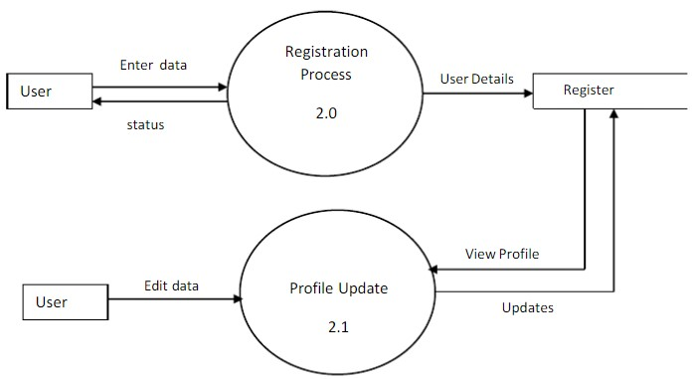

DFD for Shopping and checkout Process:

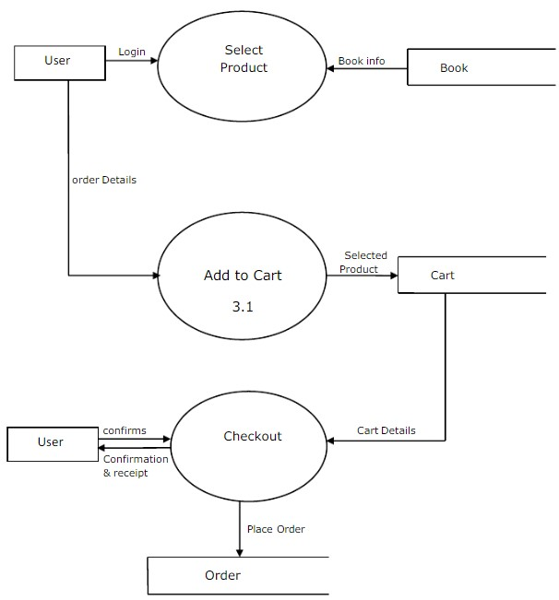

**3.3.2 Development, Testing and Review Phase**

Development phase includes writing codes using programming languages. The application will be programmed using Java and the database. This process will be repeated until the client is satisfied with the final product.

Maintaining Phase test the application's functionality. This process will take place in parallel with the development phase. This is to check that the programmed codes are working properly and that there are no errors in the coding.

Review Phase includes obtaining feedback from users and testers. This process will be followed once the finalized application is created. This process is necessary in order to develop the platform in the future. For the evaluation process, this website will be shared with a group of users or testers.

**4. DESIGN**

**4.1 Introduction**

The design phase of the system development process determines the best solution for the problem that was found during the analysis phase. The suggested system's comprehensive blueprint is produced at the end of the design phase. This chapter discusses popular software development processes and the proposed application, alternative solutions, design techniques, and the mobile application of online Book Store overall design.

**4.2 Development Strategy**

The development strategy is the path to follow in order to meet the requirements that have been identified. In terms of the online Book Store App, numerous strategies have been considered. Purchasing a set of commercial software can decrease development costs and time while also providing more quality, but you may have to pay for certain needless features, it may not match all of your requirements precisely, and it is not configurable. Standalone systems have advantages such as being simple to set up and maintain, having fewer incompatibilities, and having less security risks, but they are unable to handle remote users.

The flamingo book store application chose to construct mobile application from scratch as its development strategy. When software is built from scratch, the end result is software that is exactly aligned to the defined requirements. In addition, a highly configurable and upgradeable solution with few incompatibility difficulties is created. The ability to serve remote users via a mobile based system is critical in order to meet needs such as allowing clients to place orders, searching for books, and tracking order status and also for literature college students to exploring new books, browsing through various genres to discover her next read.

**4.6 User Interface Design**

One of the most important factors in determining an application's user friendliness is its user interface. Because it is the component with which the user interacts. The following are some of the guidelines that are to be followed:

Colors, text styles, component structure and functionality, such as navigations, should all be consistent across all interfaces.

All interface effects and dynamic changes should have a clear meaning for the user, such as links with a red pointer cursor for deletion or deletion warning, and so on.

It should be simple for users to understand. Interfaces should be as basic as possible, with helpful features such as tool tips, popup messages, and notifications recommended.

Error and confirmation messages, for example, should be consistent, straightforward, and free of technical terms.

For interfaces such as forms, the data input process should be improved and as many errors as possible detected. It would be helpful to provide default values and watermarks, as well as to use lists and option buttons instead of text boxes for selecting data rather than typing.

The sections that follow illustrates some of the main interfaces and components of the flamingo book store application (eBook) and the other interfaces are shown in the project report.

4.6.1 Register and Login Interface

The system registers and login page, which is part of the developed system, is the primary interface for logging into the system. The login interface for an online Book Store App is shown in Figure 4.

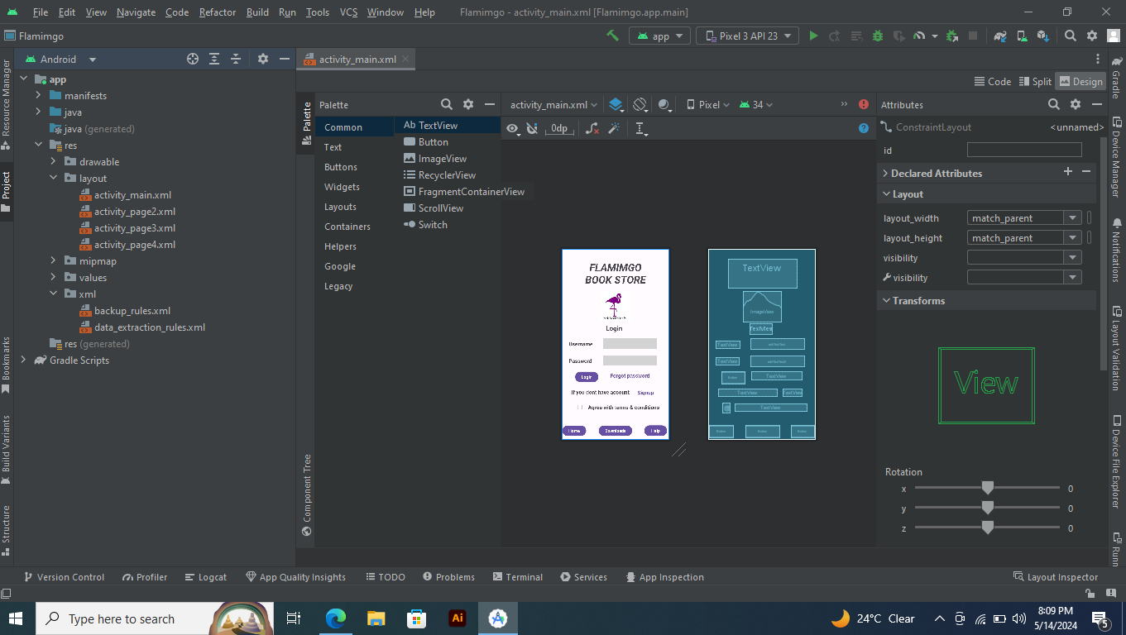

**Figure 4: Login Interface**

4.6.2 User Welcome Page

Since first impressions can influence how many people perceive your application, the application welcome page is typically the first opportunity to hook a potential customer. The welcome page of the application should be well-designed because it is the anchor that ties the rest of the application together.

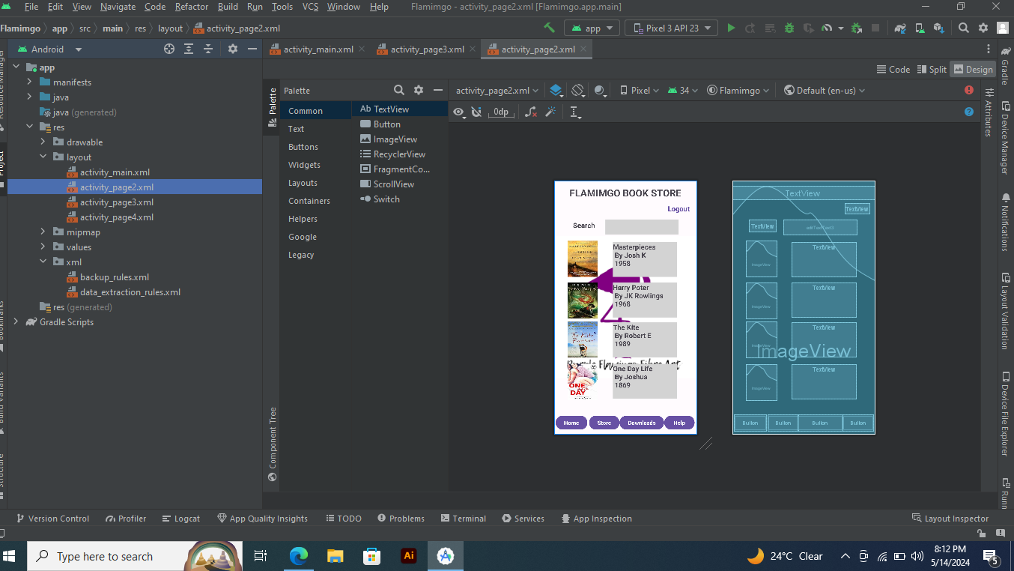

**Figure 5: User Welcome Page**

**5. IMPLEMENTATION**

**5.1 Introduction**

The implementation phase entails the development of an executable program based on the design created during the design phase. Selecting programming languages, additional tools and technologies like as frameworks, selecting hardware platforms, and coding the system are some of the main activities carried out during this phase.

The system is evaluated against multiple factors such as functional and non-functional requirements in order to guarantee that it is working properly and meets all of its specified standards during the evaluation phase of the software development process. This chapter discusses the mobile application-based system testing methodologies, test plan, and test cases, as well as test data and outputs and acceptance testing.

**5.2 Development Tools and Technologies**

JAVA for coding.

server connectivity with MySQL database.

Figma for the prototype development

**5.3 System Testing**

The planning of a testing phase is critical for both the development and completion of a system. The test plan should be able to test the overall system's functionality. By extensively testing a system, it is possible to identify and fix errors that occur as a result of the system. Multiple test scenarios are used to evaluate the implemented system. The test plan is continued to test the system units since the development begins. Upon completing the system, it is thoroughly evaluated to determine whether it could execute as planned. As a result, this testing stage assist in the early detection of errors.

Following the system unit testing, integration testing is conducted, which allows the detection of errors. To evaluate the functionality of the fully developed mobile application, system testing was performed as the final stage.

5.4 Testing Methods

In software engineering, a number of software testing methodologies and styles have been introduced to test various features of various systems.

Various styles of testing are utilized at various stages of the mobile application's development. During the design phase, unit testing is performed on each individual function of each module to check that they are correct. Following the completion of unit testing, integration testing is to be performed to check that the functionality of the modules when they interacted with one another are correct. Following the conclusion of the integration testing, system testing is to be performed on the entire system to guarantee its reliability.

**6. CONCLUSION**

**6.1 Conclusion**

Online shopping is gaining importance not only from the standpoint of the entrepreneur, but also from the standpoint of the customer, since the internet has become a vital resource in modern business. Electronic shopping opens up new business prospects for the entrepreneur, and it allows customers to compare prices. According to a report, most online shoppers are impulsive and decide whether or not to stay on a site within the first few seconds.

If the shop appears to be run-down or similar to hundreds of other shops, the customer is likely to move on to the next site." As a result, we propose to create the project to give the user as much ease of navigation, data retrieval, and essential feedback as possible. The user is given access to an online bookstore application that can be utilized to purchase books online in this project.